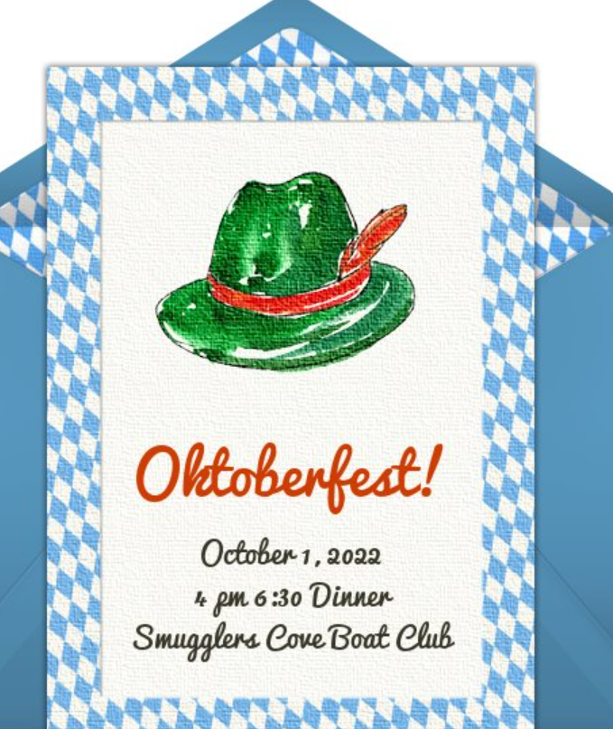

**Oktoberfest**

Saturday, October 1st, 2022

4 pm 6:30 Dinner

Smugglers Cove Boat Club

16001 Niagara River Pkwy, , NOTL, ON L0S 1J0

Hosted by Laurie and Ceri Hugill. Brenda and John Walker. Alice and Moe Waselovich

Message from the Host

Dinner at 6:30pm.

German sausage on a bun with sauerkraut, potato salad, baked beans and dessert.

Family and friend’s welcome. $10. Ea.

**BYOB**

CUT OFF SEPTEMBER 23rd