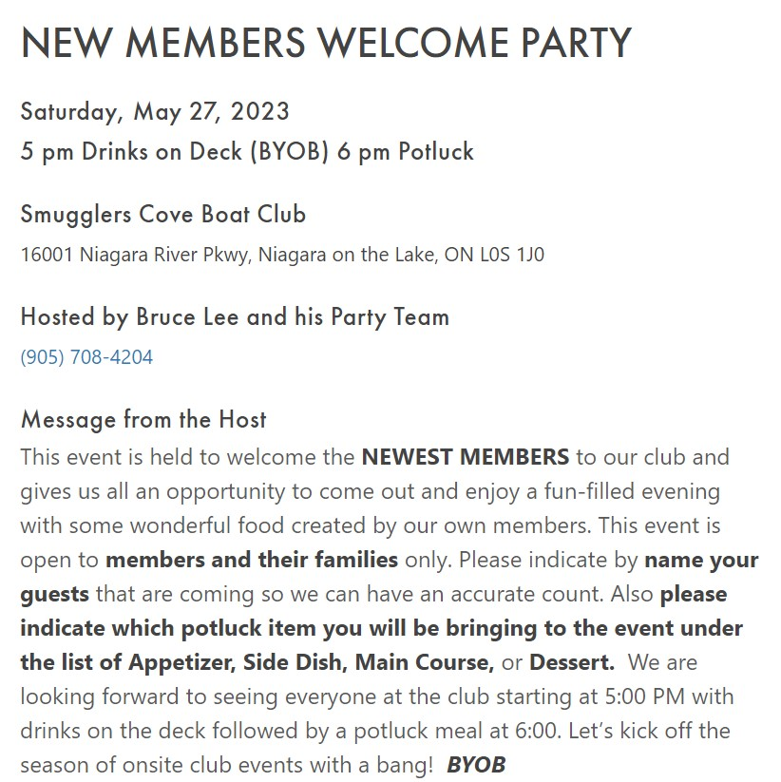

Cutoff Date: May 23rd.